Claveria, Jorlyn Shane M.
Reyes, Maria Theresa N.
Segotier, Joy Melisa S.
Estolloso, Marc Chrstian
BS INFO 3C – NAS 4_Lab 1

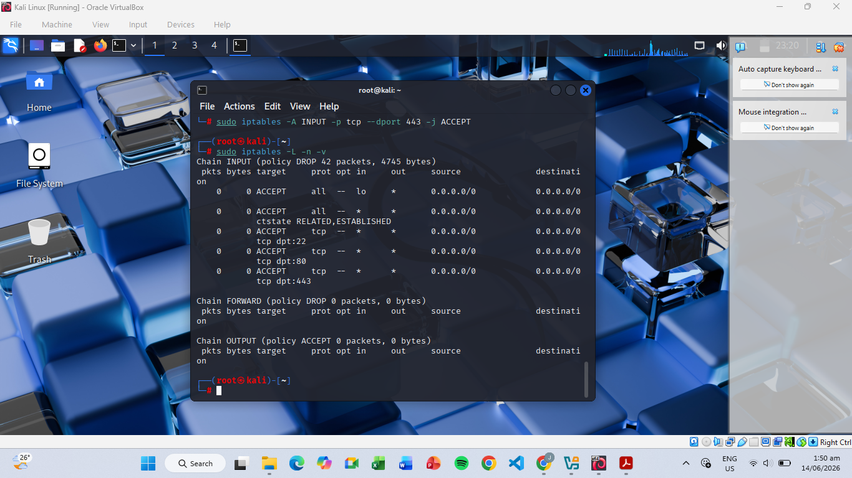
Screenshot of iptables -L -n -v showing all 5 rules (Loopback, State, SSH, HTTP, HTTPS)

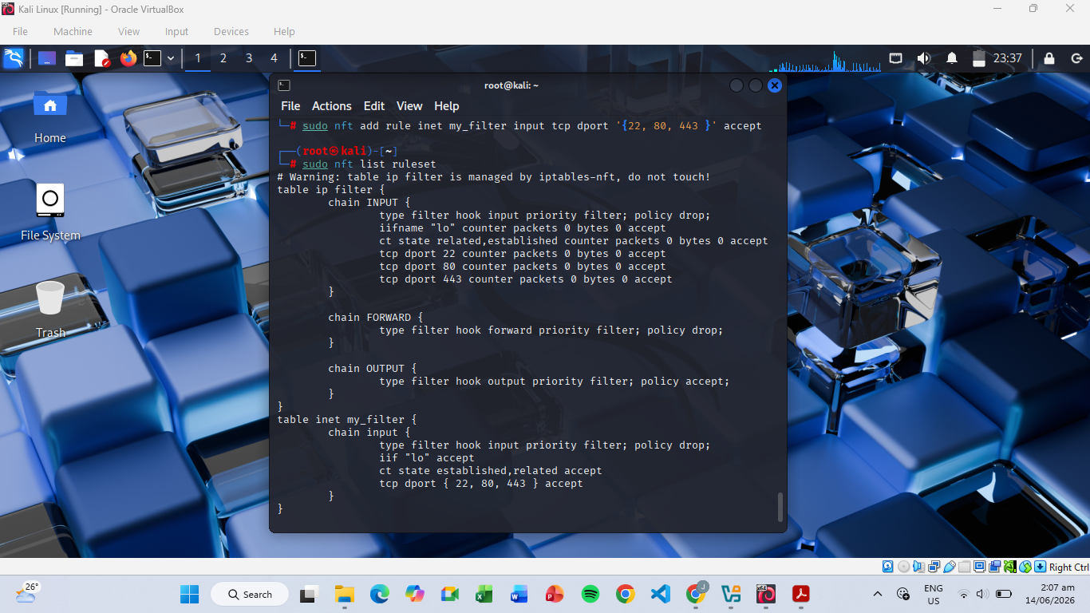
Screenshot of nft list ruleset

Written answers to the three Critical Thinking questions
1. Stateful vs. Stateless: Why did we need the ESTABLISHED,RELATED rule? What would happen to your sudo apt update command if that rule were missing, even if OUTPUT is set to ACCEPT?
The rule allows incoming packets that belong to connections initiated by the server. Without it, responses from DNS servers, package repositories, and other services would be blocked. For example, sudo apt update would send requests successfully, but the replies would be dropped.
2. Order of Operations: If you placed a DROP ALL rule at the very top of your INPUT chain, would your SSH rule at the bottom still work? Explain why.
No, iptables follows a first-match-wins principle. If the DROP rule is matched first, the packet is discarded immediately and the SSH rule below it is never checked.
3. nftables Advantage: Identify one syntax difference between iptables and nftables that makes the latter easier to manage for large-scale networks.
nftables allows multiple ports to be grouped in a single rule: tcp dport { 22, 80, 443 } accept whereas iptables requires separate rules for each port. This makes configurations shorter, cleaner, and easier to maintain.

